**W3VIETNAM NATIONAL UNIVERSITY, HO CHI MINH CITY**

**HO CHI MINH CITY UNIVERSITY OF TECHNOLOGY**

**OFFICE FOR INTERNATIONAL STUDY PROGRAMS**

**FACULTY OF TRANSPORTATION**

**Capstone Project**

**Design the model of the resistance moment on the electric power steering system of the VIOS and simulate its effects by using MATLAB software.**

**Instructor: PhD. Ngô Đắc Việt**

**PhD. Trần Đăng Long**

**Class:** CC19OTO1

**Name: Hồ Bình Minh**

**Student ID: 1852169**

December 27th, 2022, Ho Chi Minh City, Vietnam

**🙦 Semester 222**



1. **Student’s name**: Hồ Bình Minh - Student ID: 1852169
2. **Major**: Automotive Engineering - Class: CC19OTO1
3. **Thesis title**: Design the model of the resistance moment on the electric power steering system of the VIOS and simulate its effects by using MATLAB software.
4. **Group project title**: Study of Matlab/Simulink and application on simulation and analysis of mechanical components of the (complete) EPS system.
5. **Content:**

* Required to get fully understanding knowledge about the resistance torque between the tire force and road surface in steering mechanism especially in the EPS system.
* How wheel alignment and other factors can affect to the resistance torque in steering mechanism especially in the EPS system.

1. **Result**: Learning how the tire forces and wheel alignment can affect to the steering mechanism through the resistance moment and illustrating its effects which is showed in the result diagram from MATLAB.
2. **Product**:
   * Presentation report.
   * Poster.
   * Result diagrams
3. **Assigned day**: October 2022.
4. **Finished day**: December 2022.

The content and requirements of the thesis is already approved by the Head of Department of Automotive Engineering.

HCMC, day….... month…… year 2022 HCMC, day… . month…… year 2022

**Head of Department**  **Instructor**

**ACKNOWLEDGEMENT**

First and foremost, I want to express my gratitude to my family, who have always been by my side, accompanying, supporting, and assisting me in any way possible so that I can get to where I am now. I want to thank the teachers at Bach Khoa University in general and the Department of Automotive Engineering for their efforts. The knowledge I have gained from teachers over the last four years has assisted me in being brave enough to complete this project.

Sincere thanks to PhD. Ngo Dac Viet, PhD. Tran Dang Long created conditions for me to study, practice, and conduct field surveys.

Finally, I want to thank the reviewer and department lecturers for sharing their knowledge and providing me with feedback and suggestions so that I could finish this project.

Wishing health to parents, family, lecturers in the Faculty of Transportation Engineering as well as lecturers in the Department of Automotive Engineering and all of my friends in class CC19OTO1.

**ABSTRACT**

Vehicle steering dynamics is an essential topic in development of safety driving systems. These complex and integrated control units require precise information about vehicle steering dynamics, especially, tire/road contact forces. In the term of interaction between tyre force and road surface, we are going to primarily focus on the aligning moment which is the factor torque that urges the tyres to steer. This resistance moment that causes this will be described in below when considering the slip angle, the mass of vehicle, wheel alignment, lateral force generation, longitudinal force generation and normal force generation. Through this capstone project, this torque will be fully showed with the theoretically corresponding equation and combine with the result diagrams by using MATLAB software.

**LAYOUT**:

I/ INTRODUCTION: 5

**1)** **Objective:** 5

**2)** **Scope of implementation:** 5

**3)** **Working condition:** 6

**4)** **Technical requirement:** 6

**5)** **Mission summary:** 6

II/ THEORETICAL BASICS: 6

**2.1)** **General Steering Dynamics Theory:** **6**

2.1.1 Coordinate systems: 6

2.1.2 Model terminology 8

**2.2)** **Steering System Modeling and Wheel Placement theory:** **9**

2.2.1 Steering system overview: 10

2.2.2 Wheel alignment: 13

III/ VEHICLE STEERING DYNAMICS : 15

**3.1) Mathematical modelling of tire force:** **15**

**3.2) Mathematical modelling of tire moments:** **17**

3.2.1. The aligning moment by longitudinal force: 17

3.2.2. The aligning moment by lateral force: 18

3.2.3. The aligning moment by normal force: 22

IV/ RESULT AND DISCUSSION: 26

**4.1) The aligning moment with varying Caster and Kingpin angle 27**

**4.2) The aligning moment with varying in lateral force 29**

V/ CONCLUSION AND FUTURE PLAN: 32

VI/ REFERENCES: 33

# I/ Introduction:

1. **Objective:**

During the past years, steering mechanism and its relevant fields has been researched and developed in gradually increasing numbers. The reason for this point is the steering mechanism plays an important role in vehicle control. To get fully understanding knowledge about this system, at first, we need to know the interaction between the tire force and road surface especially the aligning moment of the tire apply on the steering mechanism.

The focus of this project is that we can get a deep study as much as possible on the resistance moment on the steering mechanism and its dependence on the difference of tire forces. Besides, I will choose the Electric Power Steering system which is built based on the Ackerman steering mechanism for modelling and analyzing.

Figure 1: Electric Power Steering system structure

1. **Scope of implementation:**

The model is developed to present vehicle behaviour when driving in normal condition of roads and cars, so it can not be reliable in non-linear conditions (When the vehicle is driven up to its limits). The model developed in this project does not represent the steering condition in parking situations. The model is developed by assuming that the wheels are in contact with the road surface. So, the wheel lift phenomenon is assumed negligible in this model. Besides, the resistance moment that acting on the wheel withstands a lot of types of force: longitudinal force, lateral force, and wheel alignment angle: kingpin angle, caster angle, camber angle, etc. In this project, this resistance torque is going to be fully considered in the effect of tire forces with the specific wheel alignment.

1. **Working condition:**

Continuously change to adapt with variable driving conditions.

1. **Technical requirement:**

Working normally in above condition.

1. **Mission summary:**

As I mentioned on the scope of implementation, this project is mainly going to be focus on the resistance torque under the effect of wheel alignments and other specific factors such as vehicle mass, steering angle and so on. Base on this scope, I will divide the whole objective into 2 main missions: The first one is get fully understanding knowledge about the resistance torque between the tire force and road surface in steering mechanism especially in the EPS system and the second one is how wheel alignment and other factors can affect to the resistance torque in steering mechanism especially in the EPS system.

**Summary table of the resistant torque acting on the EPS steering system for wheel alignments**

|  |  |  |  |  |  |
| --- | --- | --- | --- | --- | --- |
|  | Camber angle | Caster angle | Kingpin angle | Equation for the resistant torque | Illustration |
| Longitudinal forces |  | X | X | ]  While:  *“DESIGN OF STEERING WHEEL FORCE FEEDBACK SYSTEM WITH FOCUS ON LANE KEEPING ASSISTANCE APPLIED IN DRIVING SIMULATOR”* |  |
| Lateral forces | X | X | X | While: , and trail  *“DESIGN OF STEERING WHEEL FORCE FEEDBACK SYSTEM WITH FOCUS ON LANE KEEPING ASSISTANCE APPLIED IN DRIVING SIMULATOR”* |  |
| Normal force |  | X | X | *“DESIGN OF STEERING WHEEL FORCE FEEDBACK SYSTEM WITH FOCUS ON LANE KEEPING ASSISTANCE APPLIED IN DRIVING SIMULATOR”* |  |

# 

# II/ Theoretical basics:

* 1. **General Steering Theory:**
     1. **Coordinate systems**:

In the following section, the basic concepts of the coordinate systems used in this project will be presented. In this model, the ISO coordinate systems are used. They are based on the seven coordinate systems as following:

* Earth (X, Y, Z)

The global coordinate system describes the entire environment of the model. It is used as the position reference for the vehicle because of the global coordinate system which does not move.

* Vehicle (x, y, z)

The Center of Gravity (COG) coordinate system describes the position of COG during simulation. In this coordinate system, the x-axis is parallel to the longitudinal movement of the vehicle and points to the front of the vehicle. The yaxis is parallel to the lateral movement of the vehicle and the Z axis is parallel to the vertical movement of the vehicle.

* Wheel (xw, yw, zw)

The wheel coordinate system is in the center of each wheel. In this coordinate system, the x-axis points to the heading of the wheel.

* Path (xp, yp, zp)

The velocity coordinate system is fixed to the center of gravity of the vehicle. The difference of the center of gravity positions follows the velocity vector of the vehicle such as: longitudinal velocity (in x axis direction), Lateral velocity (in y axis direction), vertical velocity. (in z axis direction)

* Yaw (ψ)

Yaw is the rotation around the vertical axis (z-axis) through the center of gravity of the vehicle. The yaw can be felt in skidding or spin movement.

* Pitch (φ)

Pitch is the rotation around the lateral axis (y-axis) through the center of gravity of the vehicle. It can be felt in acceleration or braking movement around (y-axis) of vehicle.

* Roll (ϴ)

Roll is the rotation around the longitudinal axis (x-axis) through the center of gravity of the vehicle. This rotation can be felt during lateral acceleration (side-to-side movement) of the vehicle.

The overall scheme of ISO coordinate system is shown in Figure 2.1.

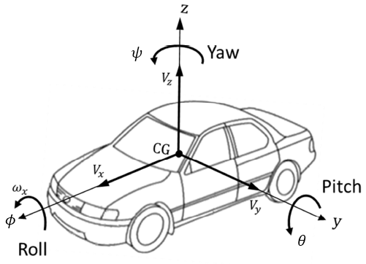

Figure 2.1.1: Overall scheme of ISO coordinate system for vehicle

* + 1. **: Model terminology**

In this part, vehicle dynamics terminology used in this project is shown in Figure 2.2 and described respectively:

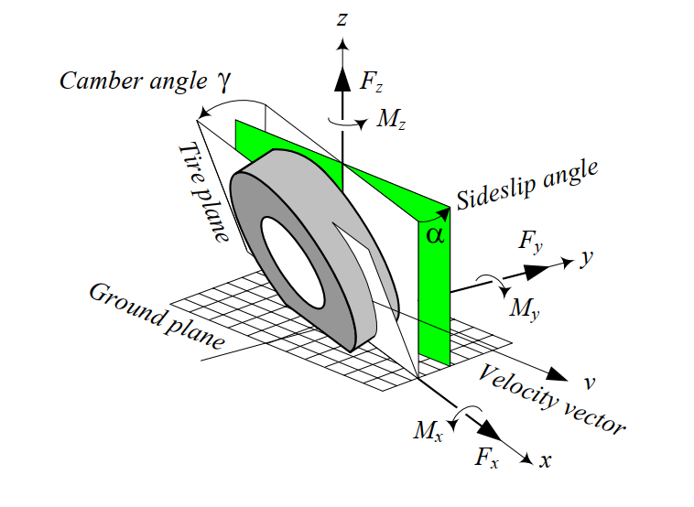 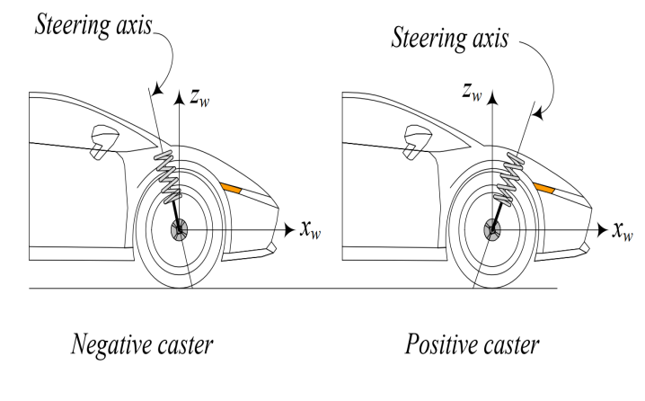

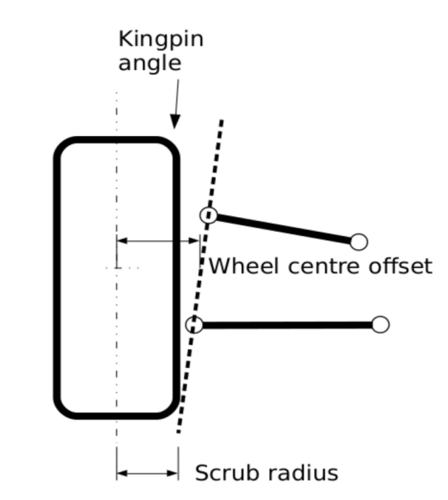

Figure 2.1.2: Vehicle dynamics terminology used in this project

As we can see in Figure 2.1.2, the tire is the main component interacting with the road. The performance of a vehicle is mainly influenced by the characteristics of its tires. Tires affect a vehicle’s handling, traction, ride comfort, and fuel consumption. To understand its importance, it is enough to remember that a vehicle can maneuver only by longitudinal, vertical, and lateral force systems generated under the tires. Steering process mainly depend on the interaction between below forces, moment, angles:

* Normal force it is vertical force, normal to the ground plane. The resultant normal force > 0 if it is upward. Normal force is also called the vertical force or wheel load.
* Longitudinal force : It is a force acting along the x-axis. The resultant longitudinal force > 0 if the car is accelerating, and < 0 if the car is braking. Longitudinal force is also called forward force.
* Lateral force It is a force, tangent to the ground and orthogonal to both and . The resultant lateral force > 0 if it is in the y direction.
* Yaw moment It is an upward moment about the z-axis. The resultant yaw moment Mz > 0 if it tends to turn the tire about the z-axis. The yaw moment is also called the *aligning moment, self -aligning moment, or bore torque*.
* Side-slip angle is the angle between the velocity vector *v* and the *x*-axis measured about the z-axis. This angle has a big influence on the steering because it directly affects on the magnitude of the lateral force
* Caster angle is the angle to which the steering pivot axis is tilted forward or rearward from vertical, as viewed from the Figure 3. This is one of the most important factors that effects on the resistance torque .
* Kingpin angle is the angle between the kingpin axis and the vertical axis  
  of the tire. The kingpin axis is the line between the lower and upper ball joints of the wheel’s hub.
  1. **Steering System Modeling and Wheel Alignment theory:**

In this part, the steering system used in this thesis is described. As mentioned before, steering system modeling is one of the most important issues in driving simulation. The high fidelity of steering system simulation is useful to achieve high reality steering feel for the driver during driving simulation. The steering system modeled during this project consists of two main parts: steering geometry and steering wheel feedback torque. Steering geometry is created to transmit the steering wheel angle applied by the driver as an input to virtual wheels angles as output. Steering wheel feedback torque has the main purpose of transmitting the torque created in a tire (self-aligning torque, friction torque…) to the steering wheel. In other words, steering system model receives the steering wheel position which is applied by the driver as input and provides the steering wheel feedback torque as output. Besides, wheel alignment angle that are necessary for only this project will also be mentioned in this part.

* + 1. **Steering system overview:**

The steering system transfers the steering wheel angle to the wheels through a mechanical system composed by a series of rods and pivots linkages. In this case when the driver turns the steering wheel, the steering wheel’s rotation is transmitted through the steering column (steering shaft) to the pinion, the pinion converts the rotation to the linear displacement through the rack and pinion. The created linear movement is transferred to the uprights through the tie roads. The created linear movement at upright generates the steering angle in the wheels. The steering mechanism between the steering box and the steering angle in the wheels presents a transmission rate which is called steering ratio. It is important to notice that the steering wheel angle and wheel angle relates via a steering ratio coefficient. Rack and pinion steering system is commonly used in conventional cars. In this project, the power steering assistance system is used as well as the rack and pinion system. A power steering assist system helps drivers by decreasing the driver’s effort in the steering wheel. The power steering assistance system is comprised of a DC motor and a control unit, so that the control unit calculates if a steering assistance is required for the driver. The rack and pinion steering system is shown in Figure 2.2.1.1 and steering box is shown in Figure 2.2.1.2 respectively.

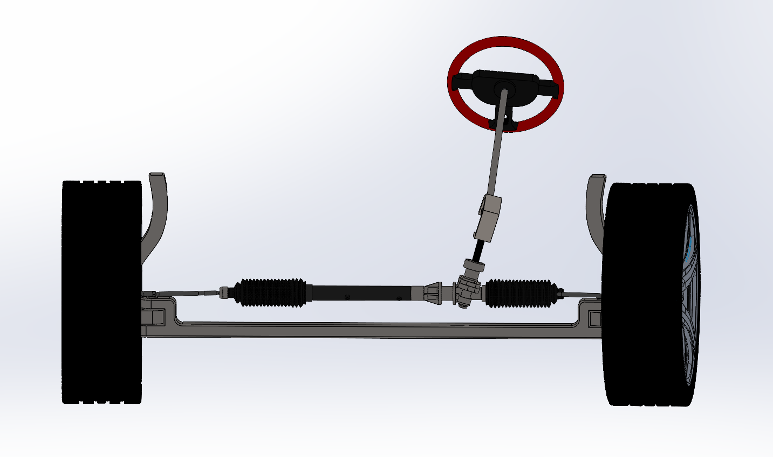

Figure 2.2.1.1: Steering systems (rack and pinion)

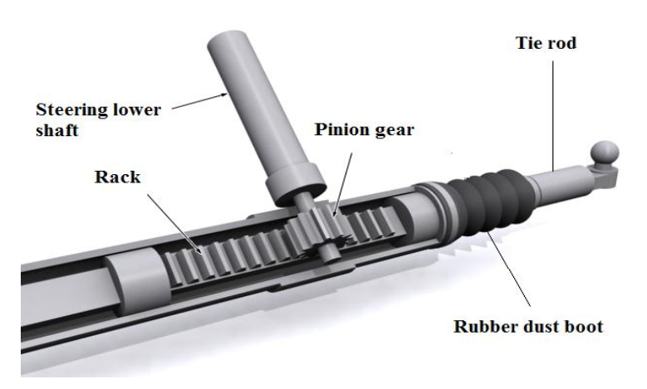

Figure 2.2.1.2: Steering gear schematic

This mechanical linkage between the steering box and the wheels usually conforms to the required condition. When the vehicle is moving very slowly, there is a kinematic condition between the inner and outer wheels that allows them to turn slip-free. It is called as Ackerman condition and expressed by:

**(*)**

where is the steer angle of the inner wheel, is the steer angle of the outer wheel, The distance between the steer axes of the steerable wheels is called the track and is shown by . The distance between the front and real axles is called the wheelbase and is shown by . Track w and wheelbase are considered as kinematic width and length of the vehicle. Ackerman steering geometry is the term used to describe the behavior of the front wheel when the vehicle is driven around a corner. In the corner when the front tires turn, the inner wheels radius is smaller than the outer wheels and that means the steering wheel is needed to generate the wheel angle for the inner wheels which are larger than the outer wheels, otherwise the inner wheel tends to slide over the road. The Ackerman geometry neglects the effect of road on tire, so it is not completely suitable for modern cars. The wheels behavior interface corner turning can be seen in Figure 2.2.1.3.

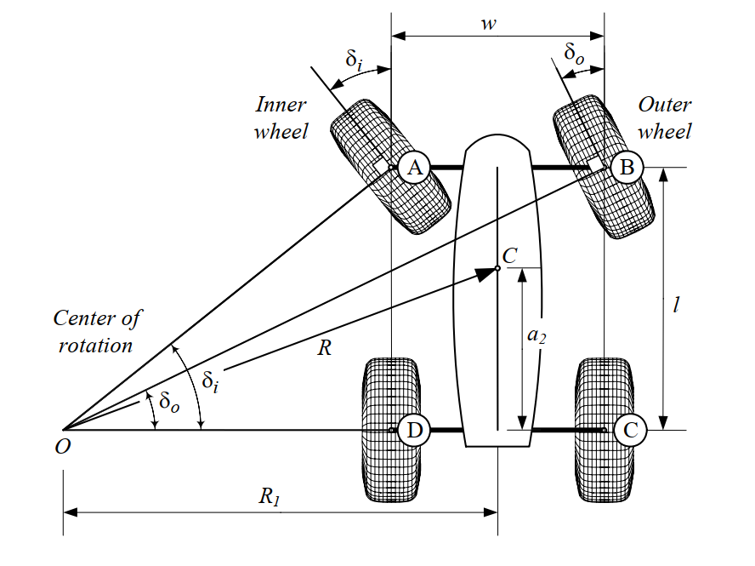

Figure 2.2.1.3: A front-wheel-steering vehicle and steer angles of the inner and

outer wheels.

As can be seen in the Figure 2.2.1.3, the inner wheel angle is larger than the outer wheel, when the vehicle turns around a circle:

It is important to notice that the wheels behavior analysis is a very important point to accurately simulate tire forces. For this reason, all the parameters which can affect the tires must consider in tire modeling.

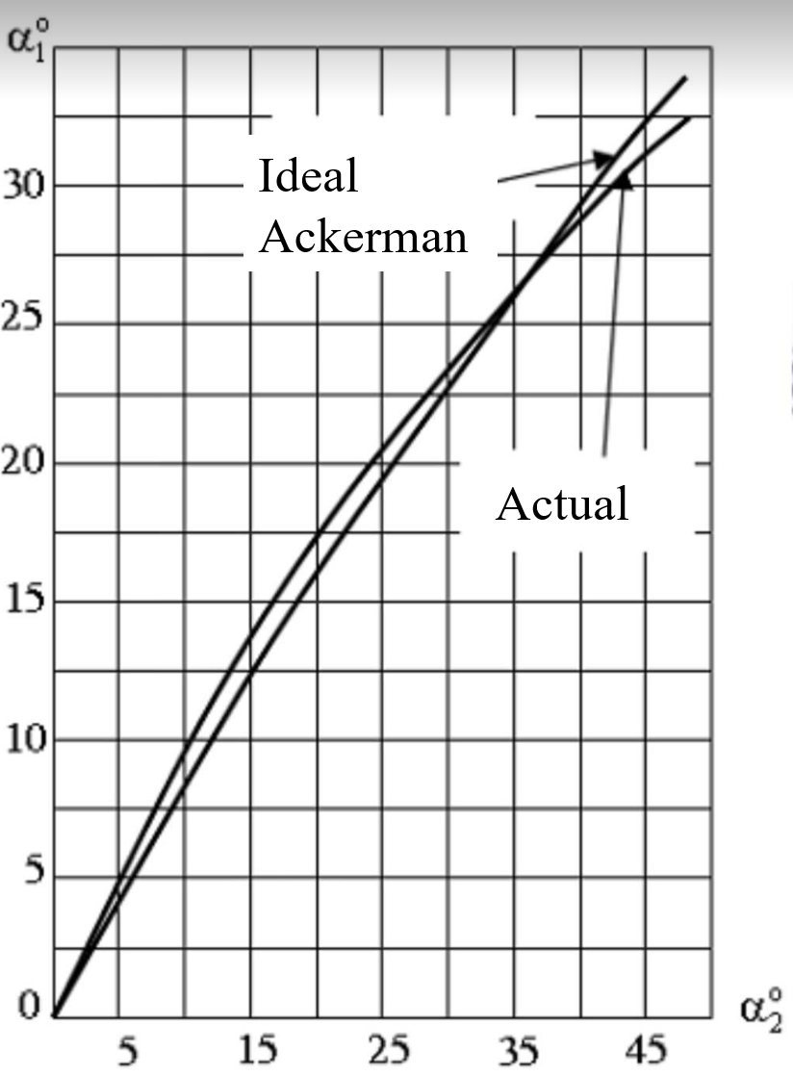

Figure 2.2.1.4: The diagram comparison about the inner and outer angle between actual condition and Ackerman condition

From the Figure 2.2.1.4, we can see that the ideal Ackerman condition and actual inner and outer steering angle have the minimum error only in the range from 0 to 35 degrees. That is the reason why in this project, the steering angle of the wheel is just under 35 degrees.

### 2.2.2 Wheel Alignment:

**Caster angle** affects the steering feel by creating a self-centering torque to reduce the toughness of steering. For example, when the caster angle is positive and the wheel is steered, the lateral forces will create a torque around the steering axis and will increase the self-aligning torque of the tire. Increasing of self-aligning torque causes the steering wheel to align quickly. Furthermore, positive caster improves the stability of vehicle in a turn and reduces under-steering situation of the vehicle when the vehicle is exiting from a turn. Positive caster angle will increase handling of the vehicle when the vehicle is turning but it causes the steering wheel to be tougher to move. When the caster angle is negative the lateral forces will produce a torque that helps steering. (Figure 2.2.2)

Figure 2.2.2: Overall in Caster angle

**Kingpin angle** has the effects which is usually discussed in terms of the scrub radius offset which determines the value of the self-aligning torque when the wheels are turned. For the zero-scrub radius, no reaction will transmit to the steering wheel and the driver is not able to perceive the change of the vehicle lateral offset. In case of the positive scrub radius (many conventional cars have a positive scrub radius offset) the wheels are returned to the straight position quickly. In case of the negative scrub radius (some modern cars have a negative scrub radius offset) the longitudinal forces will generate a moment that increases the steering of the wheels in a longitudinal direction. For this reason, the vehicle becomes more oversteering when the scrub radius offset is negative, thus the driver is not able to sense the self-aligning torque effect correctly. (Figure 2.2.2.1)

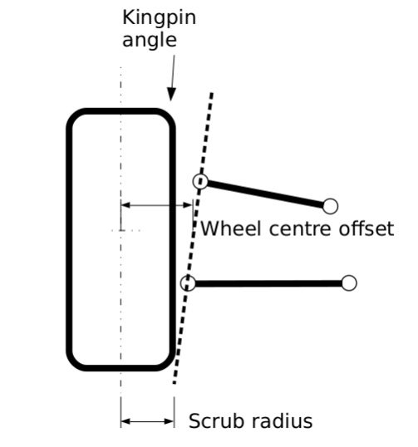

Figure 2.2.2.1: Kingpin angle and its scrub radius

**Camber angle** is the tilting angle of tire about the longitudinal x-axis. Figure 2.2.2.2 illustrates a front view of a cambered tire and generated camber force . Camber angle is assumed positive γ > 0, when it is in the positive direction of the x-axis, measured from the z-axis to the tire. A positive camber angle generates a camber force along the −y-axis. Itis directly influence on the magnitude of the lateral force which the most important factor in vehicle’s steering.

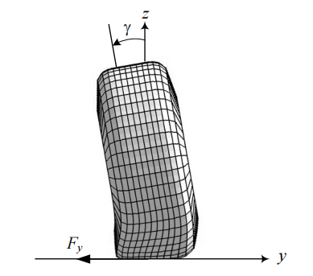

Figure 2.2.2.2: A front view of a cambered tire and the generated camber force.

In this project, only Kingpin angle and Caster angle will be considered for the resistance moment which is going to be mentioned in the next part.

**III/ VEHICLE STEERING EQUATIONS:**

**3.1) Mathematical modelling of tire force:**

* **Normal force :** has an influence on a lateral displacement between the contact point of the point of application of this force and the centre plane of the wheel. In this project, the driving situation is the vehicle speed is constant that means we have no acceleration for the normal force calculation. The Electric Power Steering system in this project is set up for the front wheel drive, so the equation of each front tire is:

**(1)**

While:

: the normal force (N)

m: mass of the vehicle (kg)

g = 9.8: gravitational acceleration (m/

the distance from the center of vehicle mass to rear axle respectively (m)

* **Lateral force** : when a turning tire is under a vertical force and a lateral force , its path of motion makes an angle α with respect to the tire plane. Basically, this force is the friction force to the centrifugal force. The angle is called side-slip angle and is proportional to the lateral force:

**(2)**

While:

Lateral force (N)

: Cornering stiffness of the tire (N/rad)

side-slip angle (rad or degree)

At the maximum lateral force, the wheel will start sliding laterally and its value will be calculated by:

**(3)**

While:

Lateral force (N)

: Normal force at the contact point of the tire and the road surface (N)

: Lateral friction coefficient

The slip angle α always increases by increasing the lateral force . However, the sliding line moves toward the tail at first and then moves forward by increasing the lateral force . Slip angle α and lateral force work as action and reaction. A lateral force generates a slip angle, and a slip angle generates a lateral force. Hence, we can steer the tires of a car to make a slip angle and produce a lateral force to turn the car. In this project, the lateral force is only considered by the effects of the sideslip angle and cornering stiffness of the tire.

* **The rolling resistance force:** In vehicle dynamics, rolling resistance force refers to the force that opposes the motion of a vehicle's wheels as they roll on the road surface. This force is caused by the deformation of the tire and the road surface, as well as other factors such as tire design, inflation pressure, and load. The rolling resistance force is calculated by equation:

**(4)**

While:

: mass of vehicle

= 9.81

= 0.011 : rolling resistance coefficient

Rolling resistance force (N)

* **Longitudinal force** : The longitudinal forces are generated between tire and road, due to the difference in velocity between road and tire, when accelerating and braking. The force is proportional to the normal force:

**(5)**

While:

Longitudinal force (N)

: Normal force at the contact point of the tire and the road surface (N)

: Longitudinal friction coefficient.

One of the most important factors that effects the magnitude of the longitudinal force is longitudinal slip ratio . This slip ratio illustrates the difference between the rotational speed of tire and vehicle longitudinal speed. The slip rate can be calculated as follows:

While:

the rotational speed of tire (rpm)

radius of tire (inch)

vehicle speed (m/s)

Increasing the slip of tire causes increasing of force as well, on the other hand, the longitudinal force is gengerated mostly depending on the construction of tire, the road condition and the vertical force applied on the tire. The main reason of force increasing is that the thread element of tire will be deformed and create the longitudinal force. The slip has linear relation with force for low slip rates, so the slope of this curve is called longitudinal tire stiffness. The longitudinal force decreases because the thread elements become saturated and unable to generate more force and the tire is locked in this condition such as Figure 3.1 illustrates below.

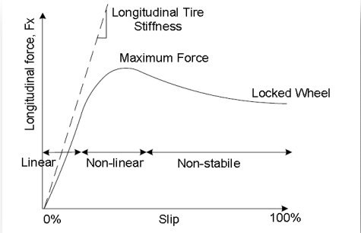

Figure 3.1: Longitudinal forces vs slip in the tire coordinate system

**3.2) Mathematical modelling of tire moments:**

In the modeling of the steering wheel feedback torque, resistance moment will be considered from the three forces of forces and wheel alignment. They are described as follows:

### 3.2.1. The resistance torque by longitudinal force:

These forces create a torque in the tire when the vehicle accelerates or brakes. The created torque in the tire due to a longitudinal force is the product of the longitudinal forces and the moment arm. The moment arm in this case is the scrub radius caused by the longitudinal forces effect, which would be sensed in the steering wheel. The total moment generated around the steering axis by can be calculated starting from Figure 3.2.1:

Figure 3.2.1: Scheme used to calculate the resistant torque generated by FX

* **Calculation diagram**:

The Figure 3.2.1 and the above diagram show the total resistance moment generated around the steering axis due to FX can be computed from:

**(5)**

While:

aligning moment caused by longitudinal force (N.m)

Longitudinal force (N)

Caster angle (degree or rad)

Kingpin angle (degree or rad)

normal scrub radius of the Kingpin angle (m)

tire radius (m)

### 3.2.2. The resistance moment by lateral force:

* **Only Caster angle:**
* Self-resistance moment in the case of pneumatic trail:

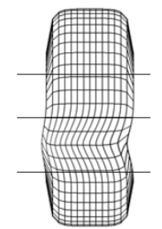 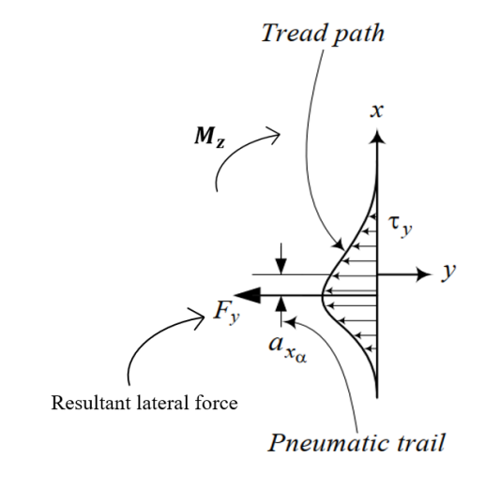

Figure 3.2.2.1: Tire print deflection and resistance moment with pneumatic trail

Figure 3.2.2.1 shows that pneumatic trail is a measure of how a tire's footprint or contact patch changes as it rolls. Pneumatic trail is caused by the progressive build-up of lateral force along the length of the contact patch, such that lateral forces are greater towards the rear of the contact patch (though less so when the rear of the contact patch begins sliding).

Pneumatic trail explains how tires can help you keep your stability and control while you drive. This effect occurs regardless of the steered direction of the tires and can result in a surf-like sensation that occurs when traveling at higher speeds. This force develops and is applied to the length of the contact patch with the rear of the contact patch experiencing the greatest pressure force. This lateral force causes the tire to rotate somewhat, which results in physical force known as self-resistance moment.

**(6)**

While:

: The resistance moment caused by pneumatic trail (N.m)

Resultant lateral force (N)

Pneumatic trail (m)

* Self-resistance moment in the case of mechanical trail:

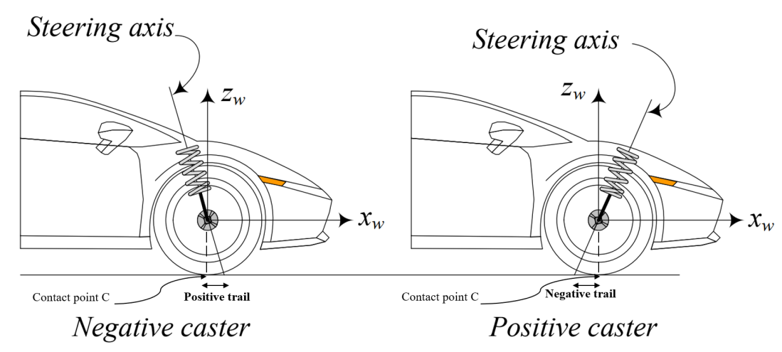

Figure 3.2.2.2: A positive and negative caster on front wheel of a car

Mechanical trail is the horizontal distance between the point where the steering axis of the front wheel intersects the ground and the point where the front tire contacts the ground which is show in Figure 3.2.2.2. In this sense, the contact patch of the tire “trails” behind the steering axis. The greater this distance, the “higher” the trail and the lower the distance the “lower” the trail. This factor also decides how much caster angle can affect on the steering feeling and how returnability of the vehicle through the resistance moment

**(7)**

While:

The resistance moment caused by mechanical trail (N.m)

Lateral force (N)

Mechanical trail (m)

As we can see in the Figure 3.2.2.3, since the trail is positive, friction force F generates a moment that tends to align the front wheel. The straightening moment is proportional to the value of the normal trail. Small positive trail values generate small aligning moments of the lateral friction force. Higher value of the trail (obtained with high value of the caster angle). If the value of the trail were negative (the contact point in front of the intersection point of the steering head axis with the road plane) and considering that friction force F is always in the opposite direction of the velocity of slippage, a moment around the steering head axis that would tend to increase the rotation to the left would be generated

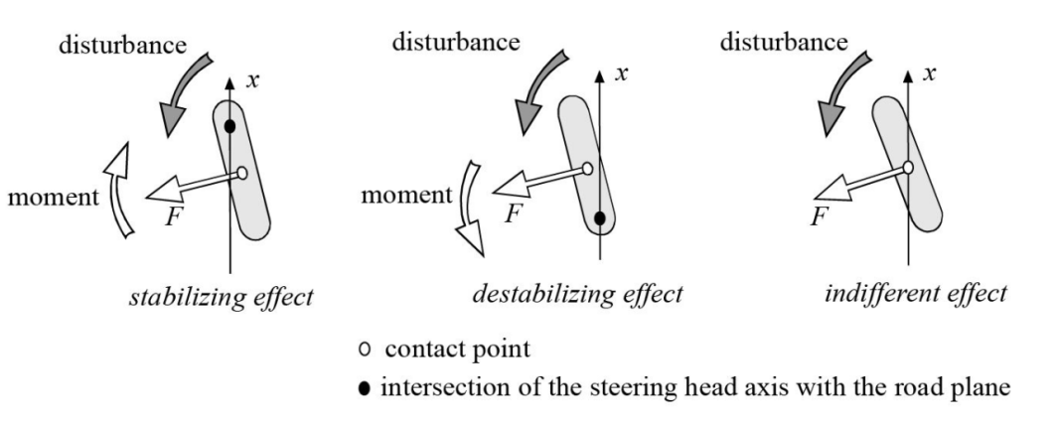

Figure 3.2.2.3: Summary of the effect of trail during forward movement

* Self-resistance moment in the collaboration of both trails

This moment tends to turn the tire about the z-axis and make the x-axis align with the velocity vector v. The resistance moment always tends to reduce α. It calculated by the equation:

**()**

While:

The resistance moment (N.m)

The resistance moment caused by pneumatic trail (N.m)

The resistance moment caused by mechanical trail (N.m)

Lateral force (N)

Pneumatic trail (m)

Mechanical trail (m)

As we can see in above equation, the self-aligning moment depend on the lateral force and the magnitude of the total trail (the sum of mechanical and pneumatic trail).

* **Kingpin and Caster angle collaboration:**

Figure 3.2.2.4: Scheme used to calculate the resistance torque generated by FY

* **Calculation diagram:**

Figure 3.2.2.4 and the diagram show the the caster, KPI and sideslip angle effect on the lateral forces of tire. So, the generated moment due to them around the steering axis can be determined from:

**(8)**

Where:

The resistance moment caused by lateral force (N.m)

Lateral force (N)

Caster angle (degree)

Kingpin angle (degree)

tire radius (m)

### 3.2.3. The resistance moment by normal force:

The resistance torque caused by normal force is one of three resistance components that oppose the steering effort of the driver. In this torque section, the main force affect to the aligning moment is the normal force which is calculated by the equation (1). The force and the moment arm will be illustrated in the Figure 3.2.3.1 below:

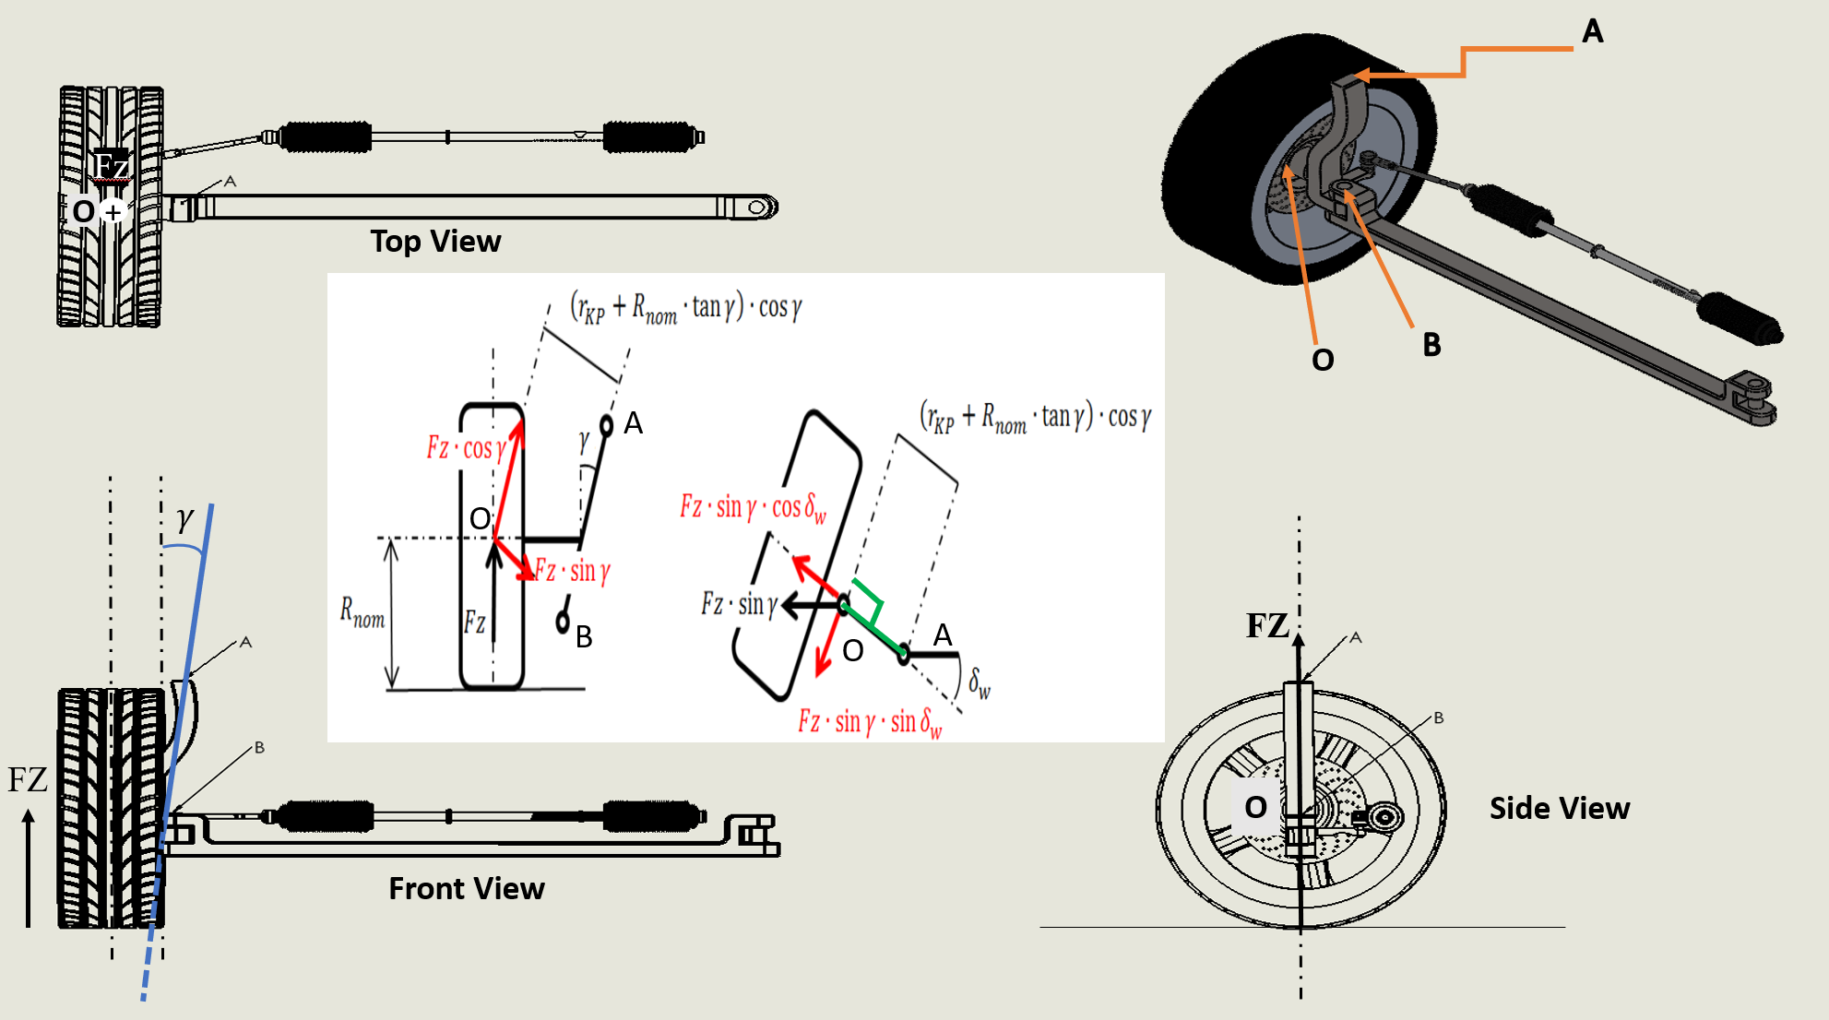

Figure 3.2.3.1: Scheme used to calculate the resistance torque generated by FZ

* **Calculation diagram:**

Figure 3.2.3.1 and the diagram show how the Caster angle, Kingpin angle and the wheel steering angle can influence on the resistance torque caused by the normal force and this torque can be calculated by the equation:

**(9)**

Where:

The resistance moment caused by lateral force (N.m)

Normal force (N)

Caster angle (degree)

Kingpin angle (degree)

tire radius (m)

: Wheel steering angle (degree)

: Scrub radius (m)

From the 3.2.1, 3.2.2, 3.2.3 sections, the total resistance torque generated around the steering axis by longitudinal force, lateral force and normal force can be calculated as:

The resistance torque by FX:

Total resistance torque

The resistance torque by FY:

The resistance torque by FZ:

**IV/ MATLAB Software:**

**4.1) Introduction MATLAB software:**

MATLAB is a digital computing software and programming language widely used in many fields, including science, engineering, finance, and business. MATLAB stands for "MATrix LABoratory" and focuses on matrix calculus and arithmetic in it. MATLAB provides a wide range of tools and functions to process and analyze data, plot graphs, and perform arithmetic and digital operations on data. It also allows users to create and run MATLAB programs to perform complex tasks. MATLAB is developed by MathWorks and is available on multiple platforms, including Windows, Linux, and macOS. MATLAB also has a wide range of auxiliary tools and toolboxes to support specific applications, including signal processing, control, computer vision, and deep learning.

Because of the wide learning fields of MATLAB, I decided to use this software to support and carry out this project simulation.

**4.2) MATLAB blocks:**

In my project, the used blocks list includes:

* Constant block: The Constant block generates a real or complex constant value signal. Use this block to provide a constant signal input.

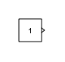

* Gain: The Gain block multiplies the input by a constant value.

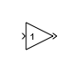

* Inport and Outport block: Provide an input and output port for a subsystem or model.

**

* Degree to Radian block: Conversion from Degrees to Radians.

* Velocity Convension block: Convert unit of input signal to desired output unit.

* Sum block: Add or subtract inputs.

* Sin and cos block: Trigonometric and hyperbolic functions.

* Product block: Multiply or divide inputs.

* Vehicle Body 3DOF Dual Track: Implements a 3 DOF rigid two-axle vehicle body model to calculate longitudinal, lateral, and yaw motion. Accounts for body mass, aerodynamic drag, and weight distribution between the axles due to acceleration and steering.

In term of lateral force calculation, I will use the longitudinal velocity, lateral velocity and yaw rate which are taken from this block to calculate the sideslip angle at the center of gravity of the vehicle as the equation (10) below:

**(10)**

Where:

sideslip angle at center of vehicle

lateral velocity at center of vehicle

longitudinal velocity at center of vehicle

After that, I will use the sideslip at center of gravity to calculate the front sideslip angle of each tire by using below equation:

**(11)**

Where:

δ: front wheel steer angle

ξ: is the angle between the X-axis and the velocity at the mid point of the front shaft.

β: sideslip angle at the center of gravity of the vehicle.

: is the distance from front tire to the vehicle’s center of mass.

: yaw rate of the vehicle’s center of mass.

: longitudinal velocity of the vehicle at center of mass.

* To workspace block: Write input to specified timeseries, array, or structure in a workspace. For menu-based simulation, data is written in the MATLAB base workspace.

# V/ Result and Discussion:

* *The result will be calculated from the mean value of the resistance moment of two front tyres*

All the parameters[1] will be taken from the table below:

|  |  |  |
| --- | --- | --- |
| **Symbols** | **Value** | **Name** |
|  | 0.03 [m] | Pneumatic trail at zero slip angle |
| g | 9.81 [m/] | Gravity of earth |
|  | [rad] | Caster angle |
|  | 0.011 | Rolling resistance coefficient |
|  | [rad] | Kingpin angle |
|  | N/rad | Cornering stiffness of tire |
|  | 0.35-0.4 | Friction coefficient |
|  | [m] | Nominal radius of tire |
|  | [m] | Wheelbase |
|  | [m] | Distance from the center of vehicle to rear axle |
|  | [rad] | Front side slip angle |
|  | [m] | Pneumatic trail |
|  | [m] | Mechanical trail |
|  | [m] | Total trail |
|  | [m] | Scrub radius |
|  | [rad] | Wheel steer angle |
|  | [N] | Longitudinal force |
|  | [N] | Lateral force |
|  | [N] | Rolling resistance force |
|  | [N] | Normal force |

Table 2: Model Parameters

## 4.1/ The aligning torque with varying Caster and Kingpin angle

For this case, we will consider the aligning moment when we keep the lateral force as a contant and change the Caster and Kingpin angle to see how they can affect to the aligning moment.

In the term of the aligning moment that have the change in Caster angle, we will assume the lateral force kN when the vertical load and the side friction coefficient are the constant (5.222 kN and 0.35[2] respectively) and the Kingpin angle rad.

Figure 4.1.1: The aligning moment and Caster angle relationship

In the term of the aligning moment that have the change in Caster angle, we will assume the lateral force kN when the vertical load and the side friction coefficient are the constant (5.222 kN and 0.35 respectively), the Caster angle rad, the total trail = 0.013 m

Figure 4.1.2: The aligning moment and Kingpin angle relationship

In the Figure 4.1.1 and 4.1.2, we can see that how the Caster angle and Kingpin angle affect to the aligning moment. If we take both as examples, there will be two opposite trendlines. At first, if we increase the Caster angle, the aligning moment also increases that corresponds with the changed Caster angle. However, if we consider the affect of the Kingpin on the aligning moment, there is a slightly downward trend which means the aligning moment will decrease if we change the higher Kingpin angle.

## 4.2/ The aligning torque with varying in lateral force

* Mass of the vehicle:

In this section, the aligning moment will be considered under the effect of the vertical load with the constant speed. Following the equation (1), we can see that the normal load which is main factor to calculate the lateral force is going to be increased with the bigger mass of the vehicle. Besides, the aligning moment is primarily based on the magnitude of the side force (as mentioned in the equation (8)). That is the reason why in the Figure 4.2.1, there is a linear trendline that shows how the mass of vehicle can affect the aligning moment.

Figure 4.2.1: The relationship between mass of the vehicle and the aligning moment

* Sideslip angle:

Figure 4.2.2: The aligning moment as a function of the sideslip angle

In the equation (4), the aligning moment caused by the lateral force primarily based on this force and the magnitude of total trail. We can see in the Figure 4.2, the slip angle α always increases by increasing the lateral force Fy and keeping the constant total trail (in this case the total trail is equal 0.013m). Slip angle α and lateral force Fy work as action and reaction. A lateral force generates a slip angle, and a slip angle generates a lateral force. Hence, we can steer the tires of a car to make a slip angle and produce a lateral force to turn the car. Steering causes a slip angle in the tires and creates a lateral force. Thanks to the increase of sideslip angle, the magnitude of the aligning moment is higher (higher lateral force), and this is the reason why the driver need to spend more steering effort at higher angle of sideslip angle.

# V/ CONCLUSION AND FUTURE PLAN:

All the steering dynamics equation are clearly mentioned in this bachelor project. Moreover, a dynamic model of a power steering system is developed by applying above knowledge. **The model can be used for performance evaluation and can be easily adapted to fit in a larger vehicle handling model**. It can also be used for the design of other power steering systems, where it allows the designer to test changes in dynamic conditions.

The main conclusion obtained in this bachelor project is how the wheel alignment especially Caster angle and Kingpin angle affect to the aligning moment. Besides, we also consider this moment under the changing in mass of vehicle. Through all the figures mentioned above, we can conclude that all of them impact to the aligning moment between the tire and road surface.

In the future, I wil continue to develop this steering mechanism model and going to simulate it by assist simulator such as MATLAB base on all relevant theories that mentioned in this bachelor project.

# VI/ REFERENCES:

1. Jazar, R. N. (2017). *Vehicle Dynamics: Theory and Application* (3rd ed. 2017). Springer.
2. Lenzo, B. (2021). *Vehicle Dynamics: Fundamentals and Ultimate Trends (CISM International Centre for Mechanical Sciences, 603)* (1st ed. 2022). Springer.
3. Cossalter, V. (2006). *Motorcycle Dynamics* (2nd ed.). Lulu.com.
4. Reimpell, J., Stoll, H., Betzler, J. W., & Engineers, S. O. A. (2022). *The Automotive Chassis: Engineering Principles* (2nd ed.). Society of Automotive Engineers.
5. American Association of State Highway and Transportation Officials. (2022). *A Policy on Geometric Design of Highways and Streets 2011* (6th ed.). Amer Assn of State Hwy.
6. Wikipedia contributors. (2022, September 13). *Vehicle dynamics*. Wikipedia. https://en.wikipedia.org/wiki/Vehicle_dynamics
7. *The caster angle: What it is and how it affects driving dynamics*. Trinacria Simracing. (2022, August 20). Retrieved December 28, 2022, from <https://trinacriasimracing.wordpress.com/the-caster-angle-what-it-is-and-how-it-affects-driving-dynamics/#:~:text=In%20common%20road%20cars%20the,on%20rear%2Dwheel%20drive%20cars>.
8. Pauwelussen, J. (2014). *Essentials of Vehicle Dynamics* (1st ed.). Butterworth-Heinemann.

Hu, C. H. (2008). Modeling and Simulation of Automotive Electric Power Steering System. *2008 Second International Symposium on Intelligent Information Technology Application*. https://doi.org/10.1109/iita.2008.51

1. *[(The Automotive Chassis: Engineering Principles)] [Author: Jörnsen Reimpell] published on (January 2004)*. (n.d.).
2. Halderman, J. (2016). *Automotive Chassis Systems (Halderman Automotive Series)* (7th ed.). Pearson.

1. Jazar, R. N. (2017). *Vehicle Dynamics: Theory and Application* (3rd ed. 2017). Springer.
2. A Policy on Geometric Design of Highways and Streets 2011 (6th ed.)